Hough Transform
Code:
import cv2
import numpy as np
image = cv2.imread('tms.jpg')
gray = cv2.cvtColor(image, cv2.COLOR_BGR2GRAY)
edges = cv2.Canny(gray, 50, 150, apertureSize=3)
lines = cv2.HoughLinesP(edges, 1, np.pi / 180, threshold=100, minLineLength=50, maxLineGap=10)
if lines is not None:
for line in lines:
x1, y1, x2, y2 = line[0]
cv2.line(image, (x1, y1), (x2, y2), (0, 255, 0), 2)
cv2.imshow('Detected Lines', image)
cv2.waitKey(0)
cv2.destroyAllWindows()

Code explation:
- Importing Libraries:
import cv2
import numpy as np
  - cv2: OpenCV library for computer vision tasks.
  - numpy: For numerical operations, especially for handling arrays (used in np.pi).
- Loading the Image:
image = cv2.imread('tms.jpg')
  - Loads the image file (tms.jpg) into the variable image. This is the image where lines will be detected.
- Converting the Image to Grayscale:
gray = cv2.cvtColor(image, cv2.COLOR_BGR2GRAY)
  - The image is converted to grayscale because the Hough Transform typically works on single-channel images. Grayscale images simplify the process of detecting edges.
- Applying Canny Edge Detection:
edges = cv2.Canny(gray, 50, 150, apertureSize=3)
  - Canny edge detector is applied to the grayscale image (gray).
  - 50 and 150 are the low and high threshold values for edge detection.
  - apertureSize=3 sets the size of the Sobel kernel used in the edge detection process.
  - The output, edges, contains a binary image where edges are marked.
- Applying the Hough Line Transform:
lines = cv2.HoughLinesP(edges, 1, np.pi / 180, threshold=100, minLineLength=50, maxLineGap=10)
  - Hough Line Transform is applied to detect lines in the edge-detected image (edges).
  - 1: The resolution of the accumulator in pixels (distance in the parameter space).
  - np.pi / 180: The resolution of the angle in radians.
  - threshold=100: The minimum number of intersections required to detect a line (votes in the accumulator).
  - minLineLength=50: The minimum length of a line segment to be detected.
  - maxLineGap=10: The maximum gap between segments that can be connected to form a single line.
The output, lines, is a list of lines detected in the image. Each line is represented by the endpoints (x1, y1) and (x2, y2).
- Drawing the Detected Lines:
if lines is not None:
for line in lines:
x1, y1, x2, y2 = line[0]
cv2.line(image, (x1, y1), (x2, y2), (0, 255, 0), 2)
  - The if lines is not None checks if any lines were detected.
  - for line in lines: Iterates through each detected line.
  - The line coordinates are unpacked into x1, y1, x2, y2.
  - cv2.line(image, (x1, y1), (x2, y2), (0, 255, 0), 2): Draws the line on the original image in green (0, 255, 0) with a thickness of 2 pixels.
- Displaying the Result:
cv2.imshow('Detected Lines', image)
cv2.waitKey(0)
cv2.destroyAllWindows()
  - cv2.imshow('Detected Lines', image): Displays the image with the detected lines.
  - cv2.waitKey(0): Waits for a key press to close the window.
  - cv2.destroyAllWindows(): Closes all OpenCV windows when the key is pressed.
Summary of Code Flow:
- Load the image.
- Convert the image to grayscale.
- Apply Canny edge detection.
- Detect lines using the Hough Line Transform.
- Draw the detected lines on the original image.
- Display the result.

Output:
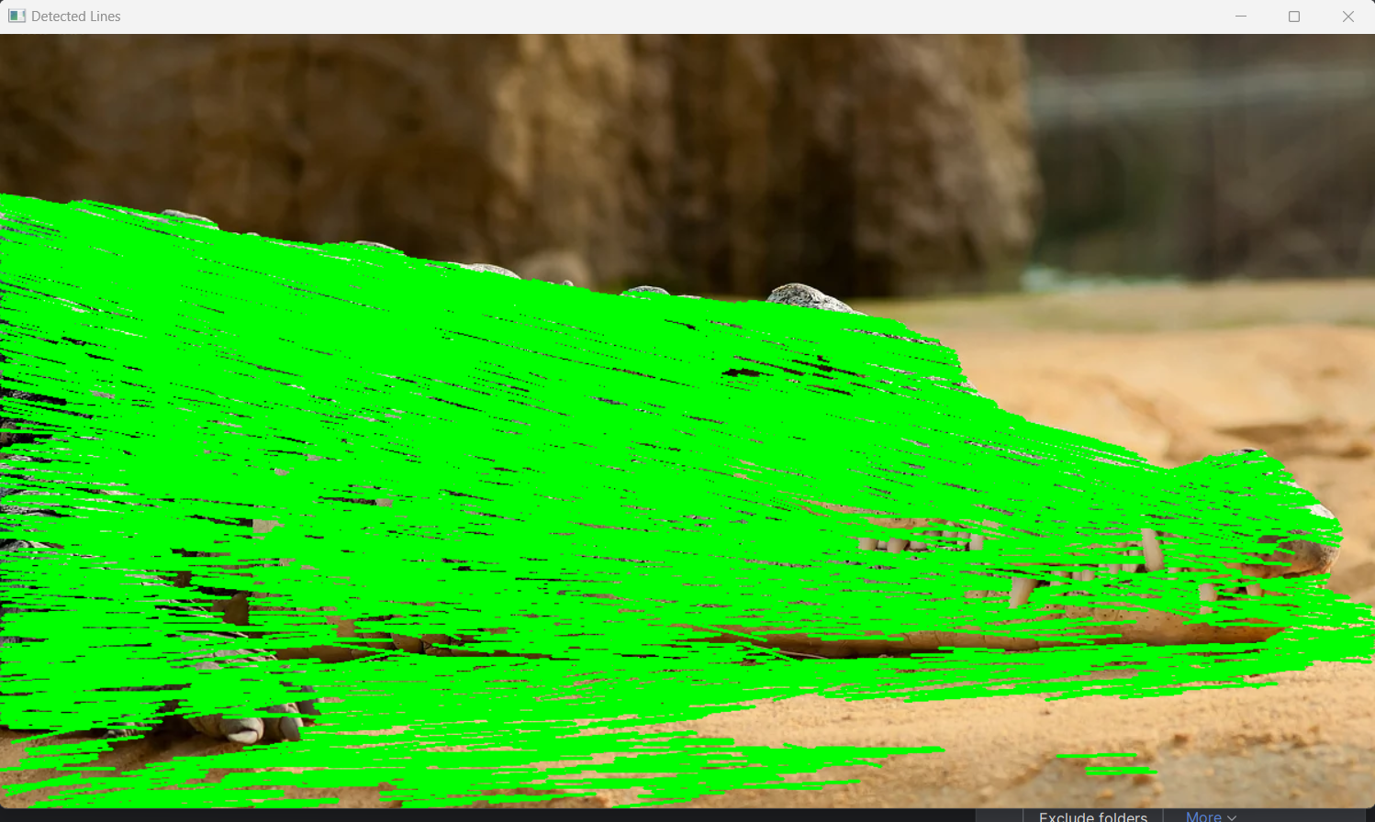

Report

1. Introduction
The Hough Transform is a method used to detect geometric shapes in an image. Specifically, the Hough Line Transform is widely used for detecting straight lines in images. This technique converts the problem of detecting lines in a Cartesian coordinate system into a simpler problem in the parameter space. OpenCV provides a convenient implementation of the Hough Transform that allows detection of lines, even in noisy images, by transforming the problem into a space where lines are easier to identify.
In this report, we will describe the process of applying the Hough Line Transform to detect lines in an image (tms.jpg) using OpenCV.

2. Objective
The primary goal of this project is to apply the Hough Transform technique to detect straight lines in an image. Using OpenCV's built-in functions, the image will be processed to extract edges and then the Hough Transform will be applied to detect lines. The detected lines will be visualized on the original image.

3. Methodology
The approach can be broken down into the following steps:
- Preprocessing:
  - Convert the input image to grayscale.
  - Apply Canny edge detection to extract the edges in the image.
- Hough Line Transform:
  - Apply the Hough Line Transform using OpenCV's cv2.HoughLinesP() function to detect line segments in the image.
- Visualization:
  - Draw the detected lines on the original image to visualize the results.

4. Algorithm
The algorithm can be described as follows:
- Load the Image: The image (tms.jpg) is loaded using OpenCV's cv2.imread() function.
- Convert to Grayscale: The image is converted to grayscale using cv2.cvtColor() to simplify edge detection.
- Edge Detection (Canny): The Canny edge detector is applied to the grayscale image using cv2.Canny(). This function detects edges by finding areas of rapid intensity change.
- Apply Hough Transform:
  - The Hough Line Transform is applied using OpenCV's cv2.HoughLinesP() function. This function finds the lines in the edge-detected image using a probabilistic version of the Hough Transform.
  - The detected lines are returned as segments with start and end coordinates (x1, y1) and (x2, y2).
- Draw Detected Lines: The detected lines are drawn on the original image using cv2.line(), where the color is set to green and the thickness is set to 2 pixels.
- Display Results: The final image with the detected lines is displayed using cv2.imshow().

5. Code Implementation
Here is the Python code implementing the above steps using OpenCV:
import cv2
import numpy as np
image = cv2.imread('tms.jpg')
gray = cv2.cvtColor(image, cv2.COLOR_BGR2GRAY)
edges = cv2.Canny(gray, 50, 150, apertureSize=3)
lines = cv2.HoughLinesP(edges, 1, np.pi / 180, threshold=100, minLineLength=50, maxLineGap=10)
if lines is not None:
for line in lines:
x1, y1, x2, y2 = line[0]
cv2.line(image, (x1, y1), (x2, y2), (0, 255, 0), 2)
cv2.imshow('Detected Lines', image)
cv2.waitKey(0)
cv2.destroyAllWindows()

6. Results and Observations
- The Hough Line Transform was successfully applied to the image tms.jpg.
- The detected lines were overlaid on the original image in green.
- The lines were accurately detected even in the presence of noise or irregularities, showcasing the effectiveness of the Hough Transform in line detection.

7. Conclusion
In this project, the Hough Line Transform was implemented using OpenCV to detect straight lines in an image. The image preprocessing steps, including grayscale conversion and Canny edge detection, were followed by the application of the Hough Transform to detect lines. The detected lines were successfully visualized on the original image.
The Hough Transform is a powerful method for detecting lines in images and is widely used in various computer vision applications such as lane detection, object recognition, and robotics.
This implementation highlights the utility of OpenCV for image processing and computer vision tasks, making it a valuable tool for real-time applications in various fields.

